EXPERIMENT NO 08

nano pract8.c
CODE:

#include <stdio.h>
int main(){
int block[5]={100,500,200,300,600};
int process[4]={212,417,112,426};
int i,j;
printf("First Fit:\n");
for(i=0;i<4;i++){
for(j=0;j<5;j++){
if(block[j]>=process[i]){
printf("Process %d allocated to Block %d\n",i+1,j+1);
block[j]-=process[i];
break;
}
}
}
printf("\nBest Fit:\n");
for(i=0;i<4;i++){
int best=-1;
for(j=0;j<5;j++){
if(block[j]>=process[i]){
if(best==-1||block[j]<block[best])best=j;
}
}
if(best!=-1){
printf("Process %d allocated to Block %d\n",i+1,best+1);
block[best]-=process[i];
}
}
printf("\nWorst Fit:\n");
for(i=0;i<4;i++){
int worst=-1;
for(j=0;j<5;j++){
if(block[j]>=process[i]){
if(worst==-1||block[j]>block[worst])worst=j;
}
}
if(worst!=-1){
printf("Process %d allocated to Block %d\n",i+1,worst+1);
block[worst]-=process[i];
}
}
return 0;
}

OUTPUT:

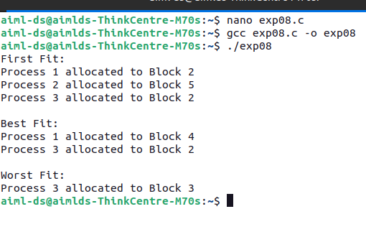\
AIM
Write a program to demonstrate the concept of Dynamic Partitioning Placement
Algorithms such as First Fit, Best Fit and Worst Fit.

RESOURCES REQUIRED
Ubuntu Operating System
Terminal
Text Editor (nano)
GCC Compiler

THEORY
Dynamic Partitioning is a memory management technique in which memory is allocated
to processes dynamically based on their size. Unlike fixed partitioning, partitions are
created when processes arrive and are removed when processes leave.
To allocate memory blocks to processes efficiently, placement algorithms are used.
1. First Fit
In the First Fit algorithm, the first memory block that is large enough to satisfy the
process requirement is allocated.
Advantages
Simple and fast.
Disadvantages
May create small unused memory fragments.
2. Best Fit
In the Best Fit algorithm, the smallest memory block that can satisfy the process
requirement is selected.
Advantages
Reduces wasted memory.
Disadvantages

Takes more time because all blocks must be searched.
3. Worst Fit
In the Worst Fit algorithm, the largest available memory block is allocated to the
process.
Advantages
Leaves larger free blocks for future processes.
Disadvantages
May cause inefficient memory usage.
These algorithms help improve memory utilization and reduce external
Fragmentation.

CONCLUSION

Thus, the program to demonstrate First Fit, Best Fit and Worst Fit memory
allocation algorithms was successfully executed.

